FRACTIONS, DECIMALS AND PERCENTAGES
Pearson Edexcel - Tuesday 19 May 2020 - Paper 1 (Non-Calculator) Foundation Tier

Pearson Edexcel - Thursday 4 June 2020 - Paper 2 (Calculator) Foundation Tier

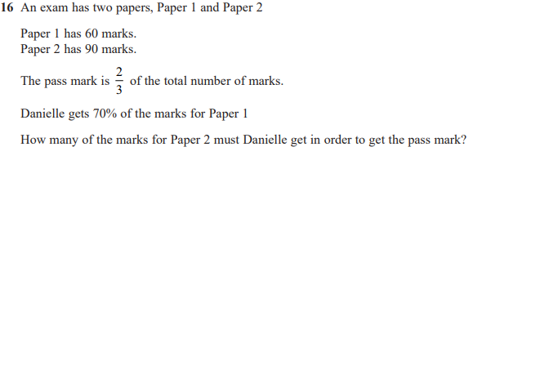

Pearson Edexcel - Monday 8 June 2020 - Paper 3 (Calculator) Foundation Tier

Pearson Edexcel - Tuesday 21 May 2019 - Paper 1 (Non-Calculator) Foundation Tier

Pearson Edexcel - Thursday 6 June 2019 - Paper 2 (Calculator) Foundation Tier

Pearson Edexcel - Tuesday 11 June 2019 - Paper 3 (Calculator) Foundation Tier

Pearson Edexcel - Tuesday 6 November 2018 - Paper 1 (Non-Calculator) Foundation Tier

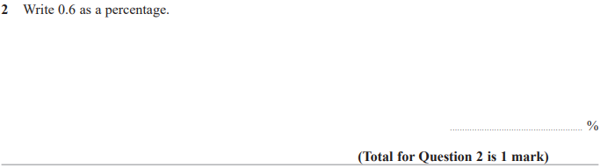

Pearson Edexcel - Thursday 8 November 2018 - Paper 2 (Calculator) Foundation Tier

Pearson Edexcel - Monday 12 November 2018 - Paper 3 (Calculator) Foundation Tier

Pearson Edexcel - Thursday 24 May 2018 - Paper 1 (Non-Calculator) Foundation Tier

Pearson Edexcel - Thursday 7 June 2018 - Paper 2 (Calculator) Foundation Tier

Pearson Edexcel - Tuesday 12 June 2018 - Paper 3 (Calculator) Foundation Tier

Pearson Edexcel - Monday 6 November 2017 - Paper 2 (Calculator) Foundation Tier

Pearson Edexcel - Wednesday 8 November 2017 - Paper 3 (Calculator) Foundation Tier

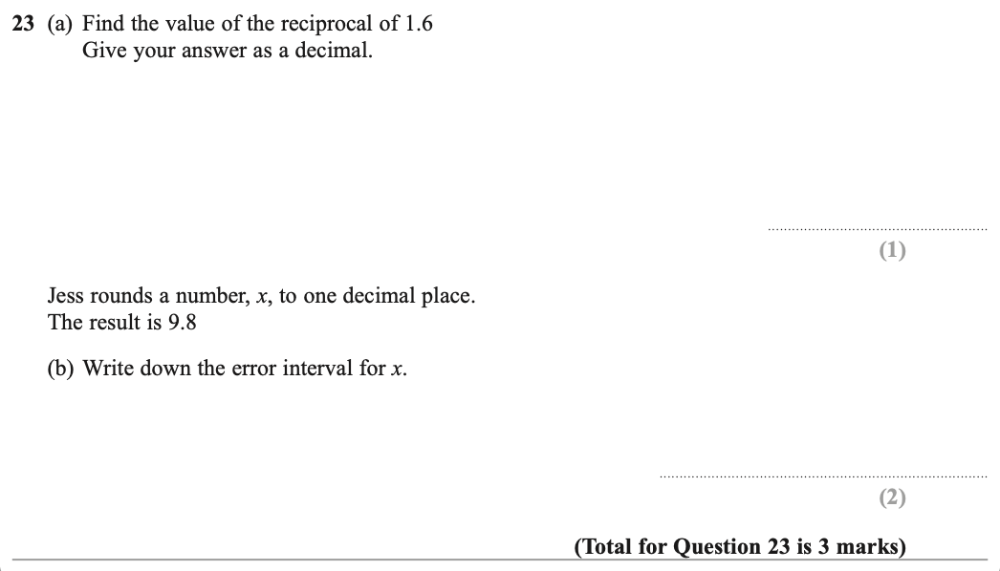

Pearson Edexcel – Specimen 2 - Paper 1 (Non-Calculator) Foundation Tier

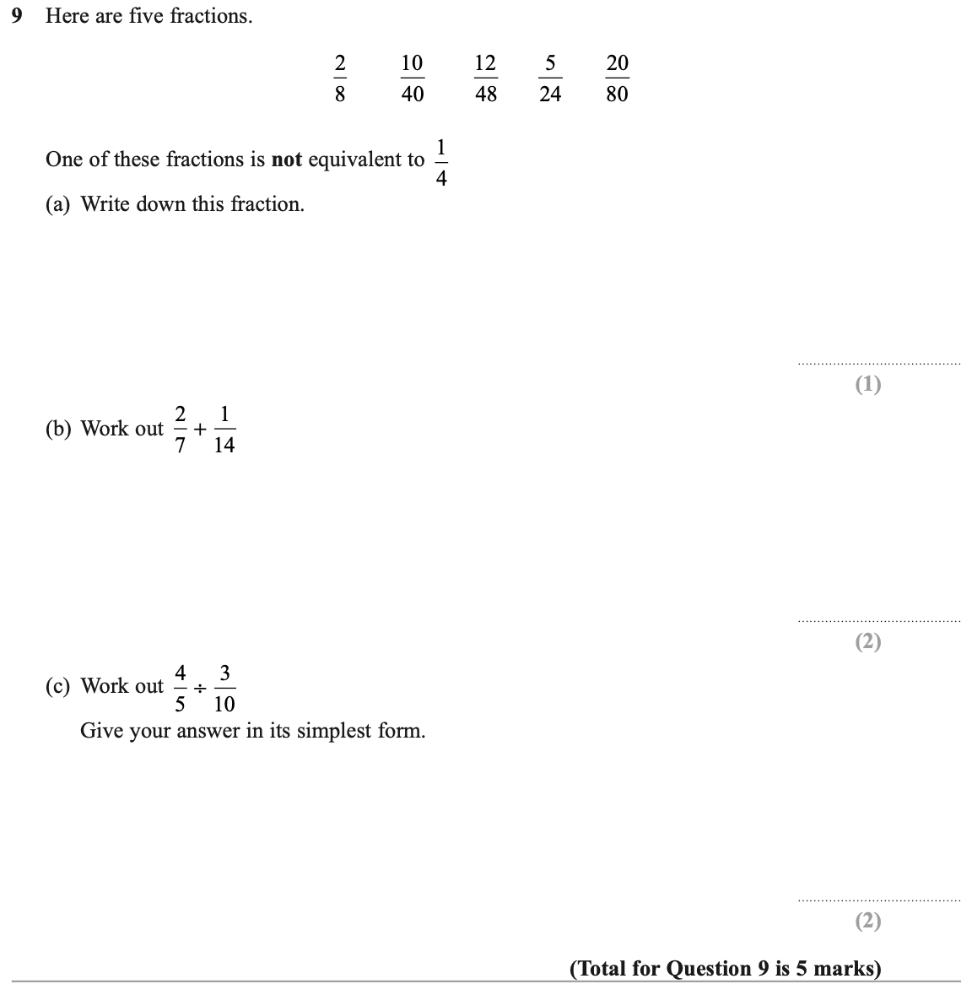

Pearson Edexcel – Specimen 2 - Paper 2 (Calculator) Foundation Tier

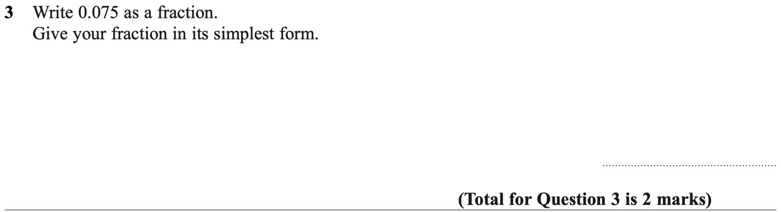

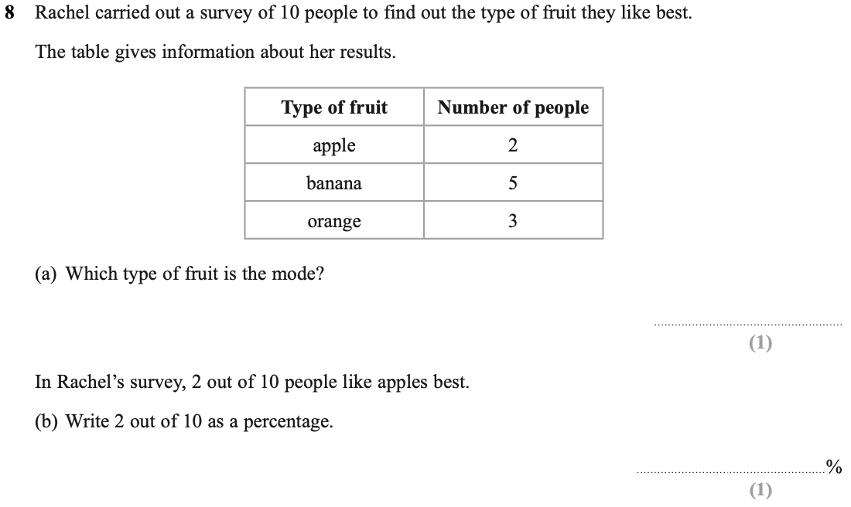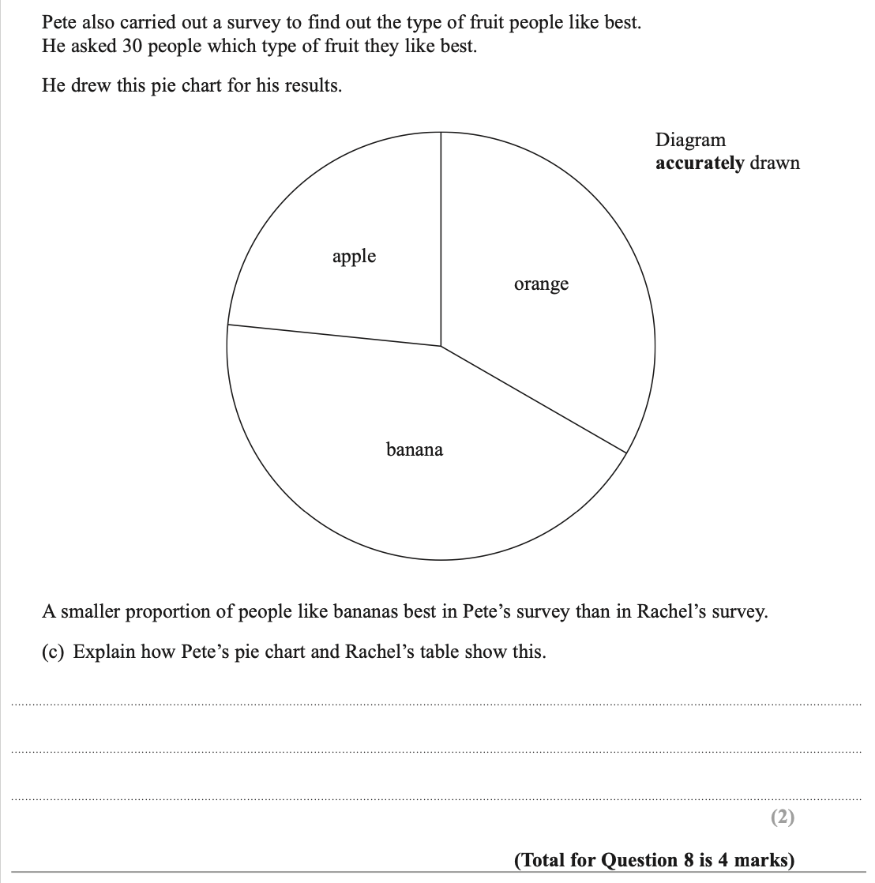

Pearson Edexcel – Specimen 2 - Paper 3 (Calculator) Foundation Tier

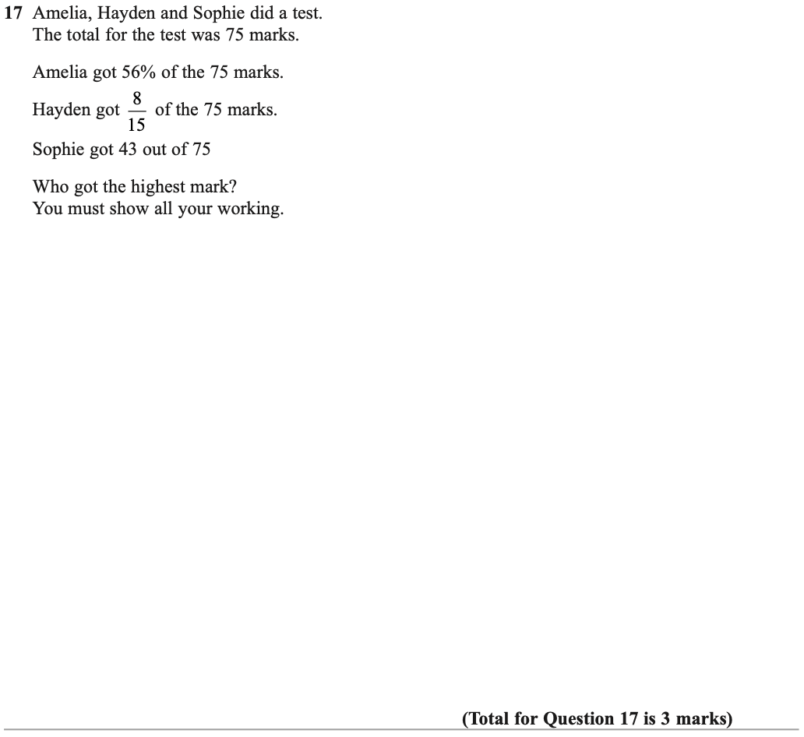

Pearson Edexcel – Specimen 1 - Paper 1 (Non-Calculator) Foundation Tier

Pearson Edexcel – Specimen 1 - Paper 2 (Calculator) Foundation Tier

Pearson Edexcel – Specimen 1 - Paper 3 (Calculator) Foundation Tier

OCR – Tuesday 03 November 2020- Morning - Paper 1 (Calculator) Foundation Tier
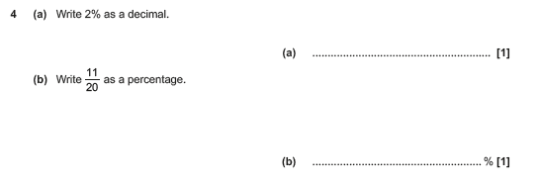

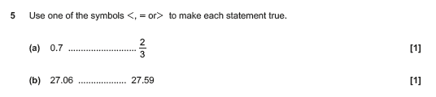

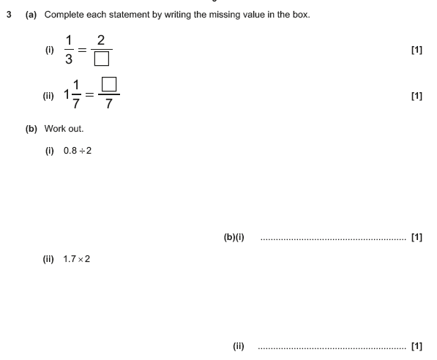
OCR Thursday 05 November 2020- Morning (Non-Calculator) Foundation Tier

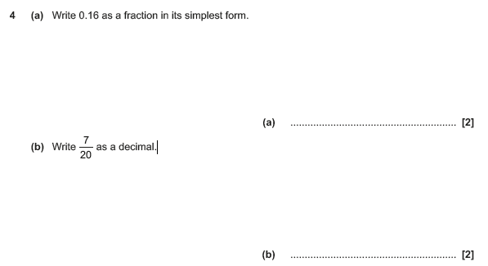

OCR November 09 November 2020- Morning (Calculator) Foundation Tier
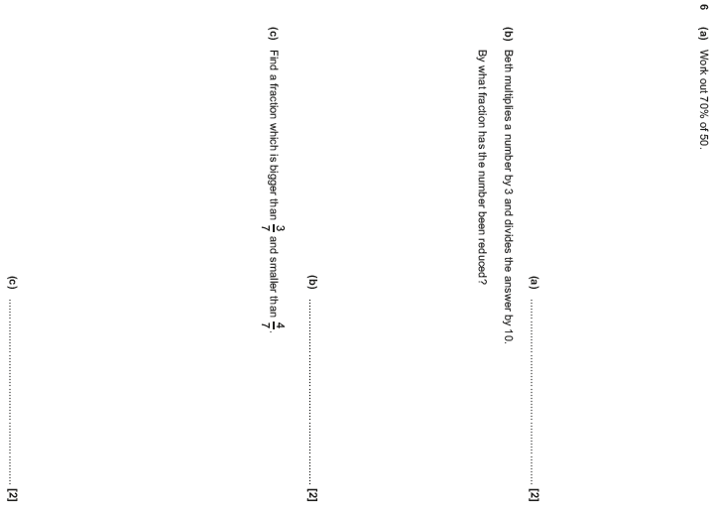

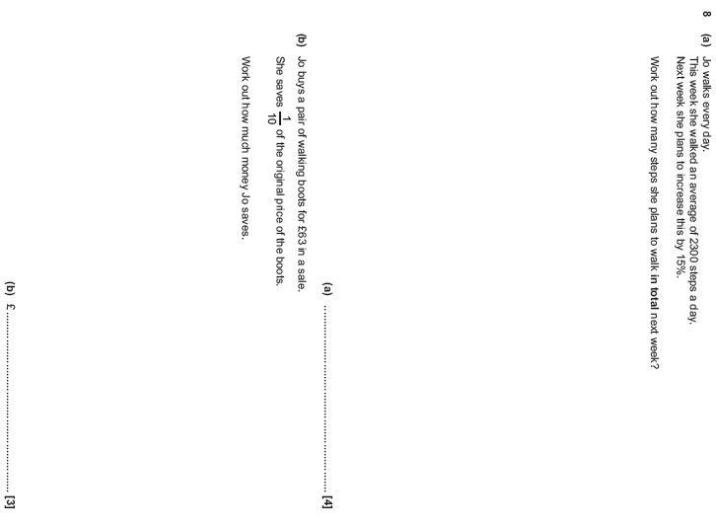

OCR Thursday 07 November 2019- Morning (Non-Calculator) Foundation Tier
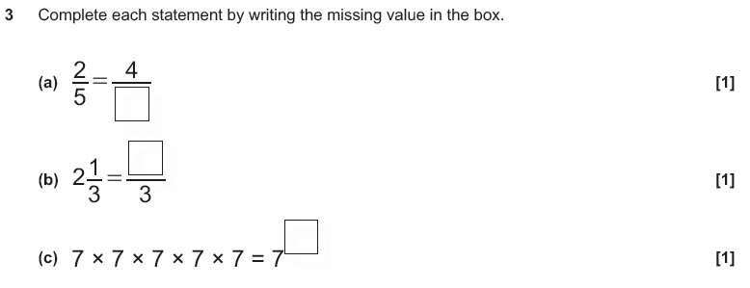

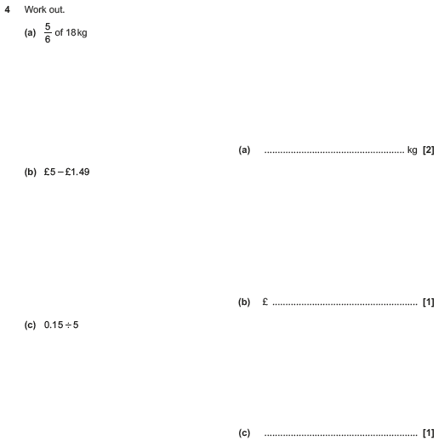

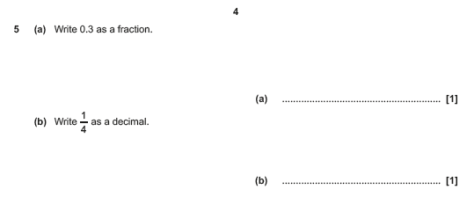

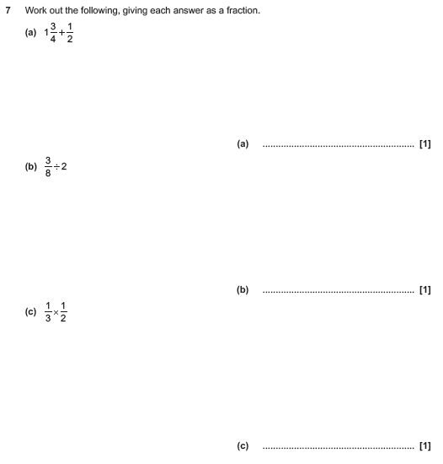

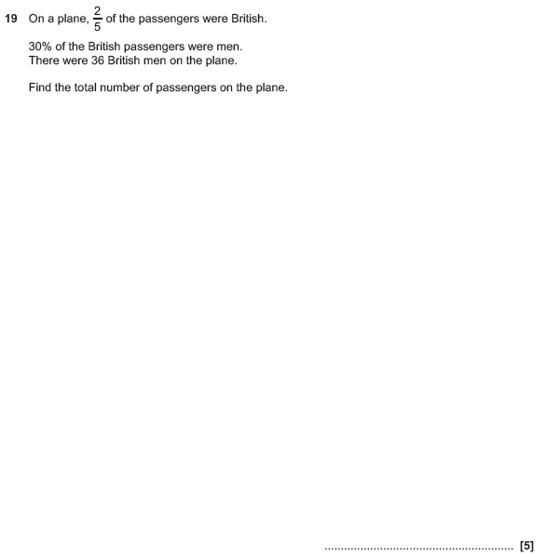

OCR Tuesday 21 May 2019 – Morning (Calculator) Foundation Tier
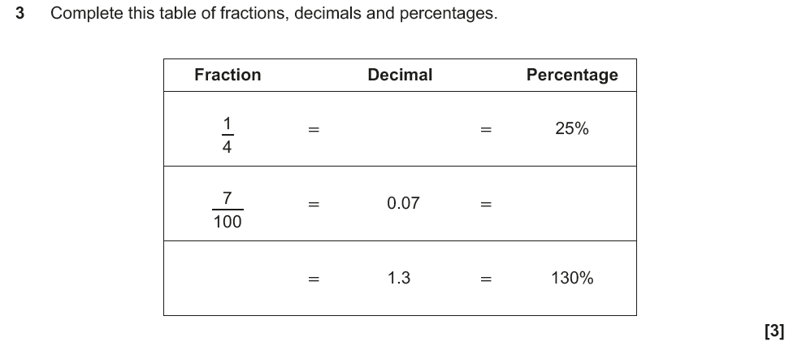

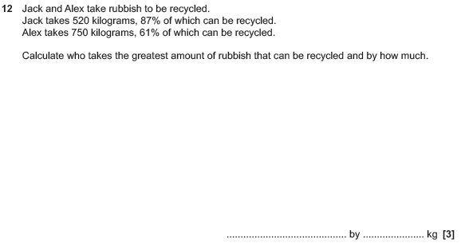

OCR Thursday 6 June 2019 – Morning (Non-Calculator) Foundation Tier
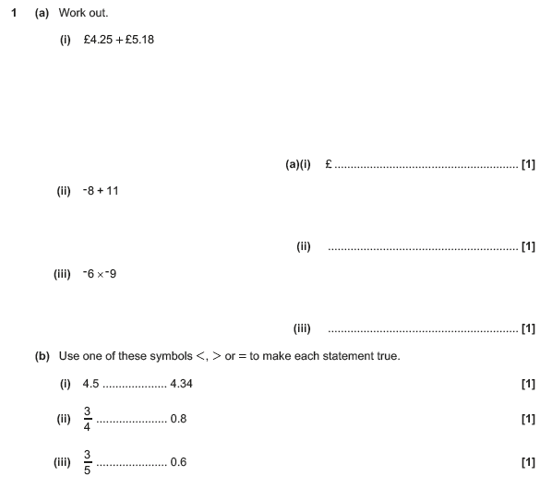

OCR Thursday 8 November 2018 – Morning (Non-Calculator) Foundation Tier
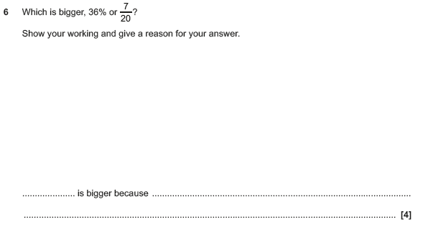

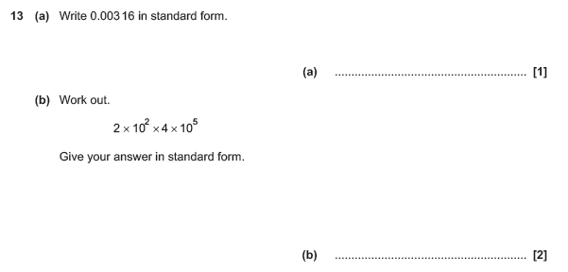

OCR Monday 12 November 2018 – Morning (Calculator) Foundation Tier
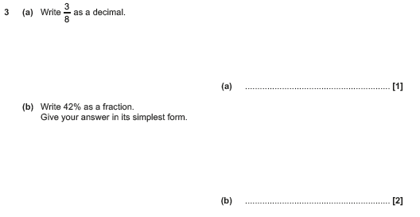

OCR Monday 24 May 2018 – Morning (Calculator) Foundation Tier
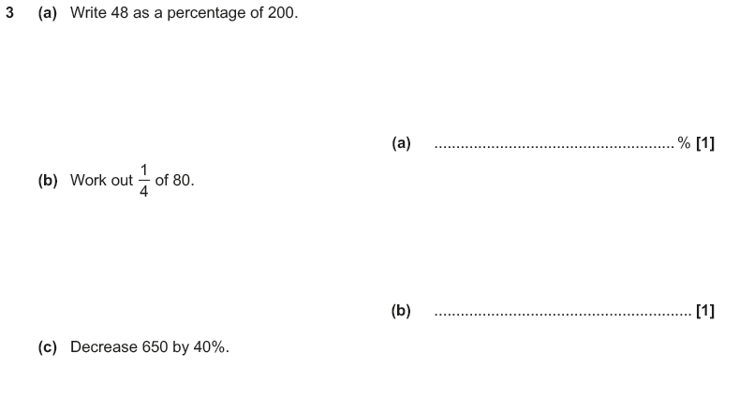

OCR Thursday 7 June 2018 – Morning (Non Calculator) Foundation Tier
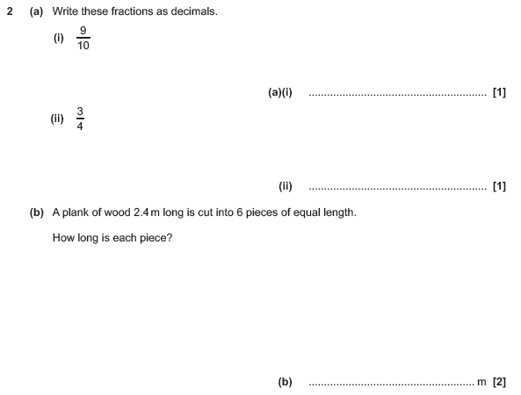

OCR Tuesday 12 June 2018– Morning (Calculator) Foundation Tier
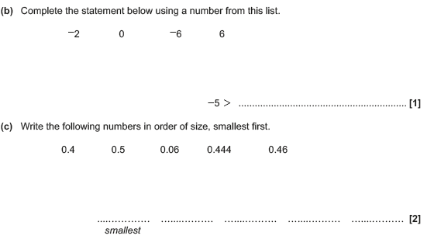
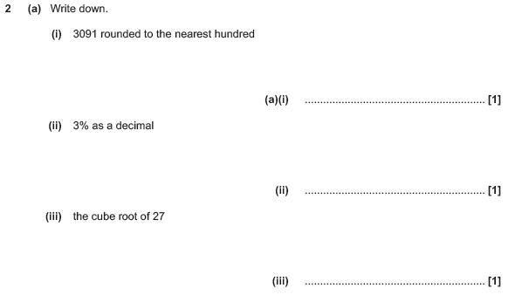

OCR Thursday 2 November 2017– Morning (Calculator) Foundation Tier
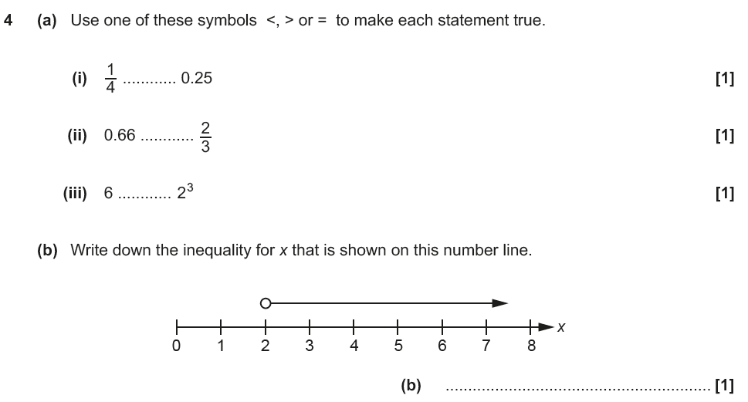

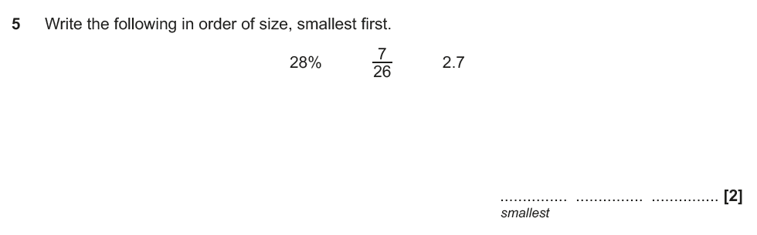

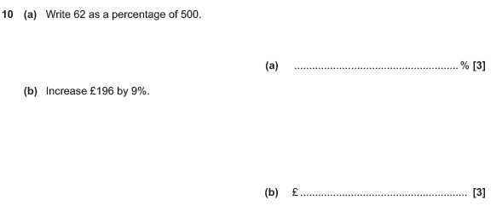

OCR Monday 6 November 2017– Morning (Calculator) Foundation Tier
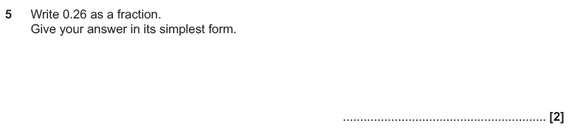

Pearson Edexcel – Sample Papers - Paper 1 (Non-Calculator) Foundation Tier

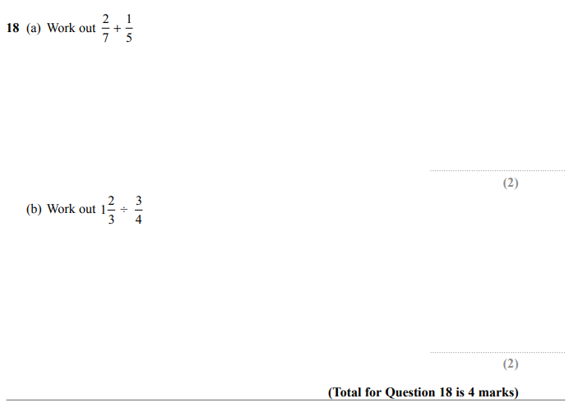

Pearson Edexcel –Sample Papers - Paper 2 (Calculator) Foundation Tier

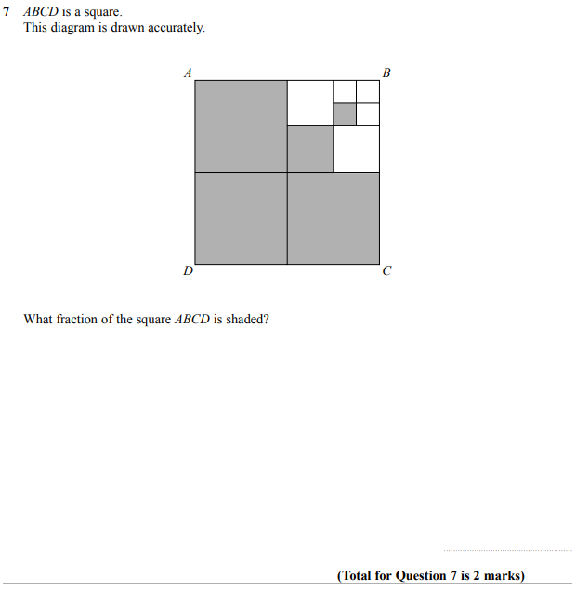

OCR Thursday 25 May 2017 – Morning (Calculator) Foundation Tier

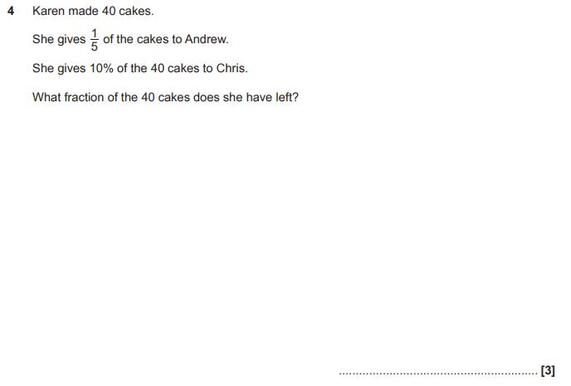

OCR Thursday 25 May 2017 – Morning (Calculator) Foundation Tier

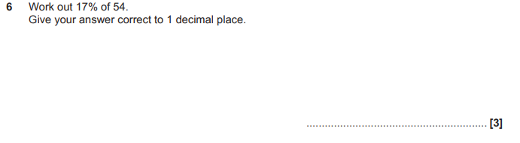

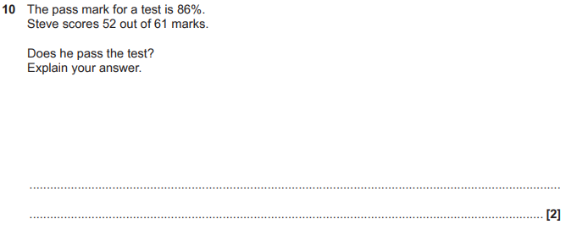

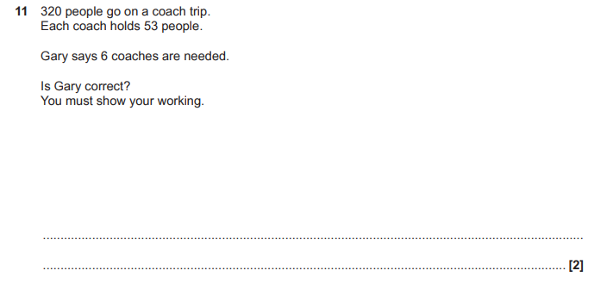

OCR Tuesday 13 June 2017 – Morning (Calculator) Foundation Tier

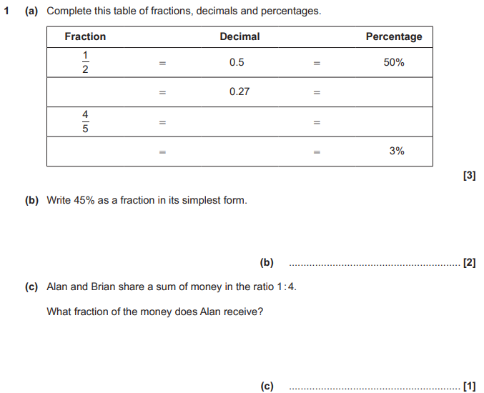

AQA Tuesday 19 May 2020 – Morning (Non-Calculator) Foundation Tier

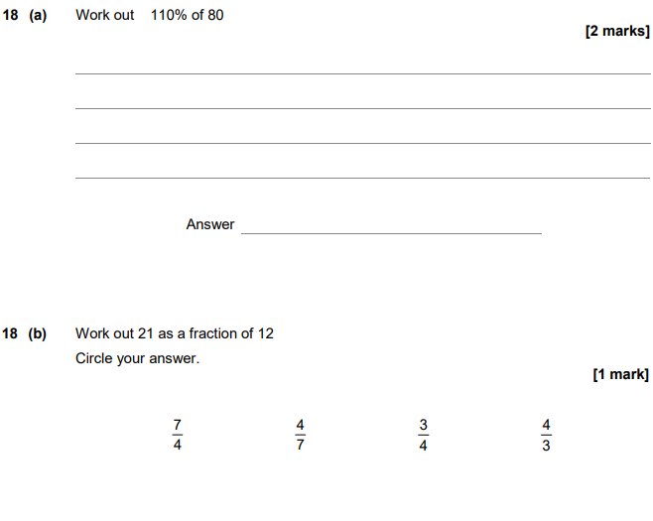

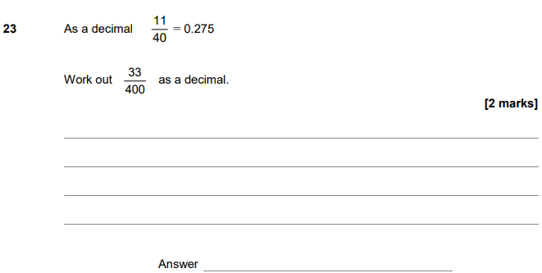

AQA Thursday 4 June 2020 – Morning (Calculator) Foundation Tier

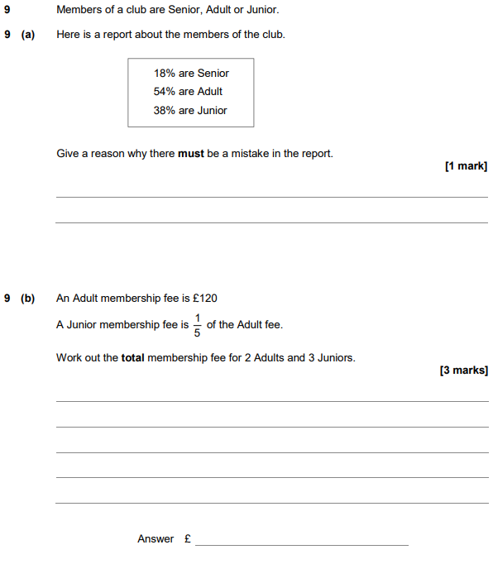

AQA Monday 8 June 2020 – Morning (Calculator) Foundation Tier

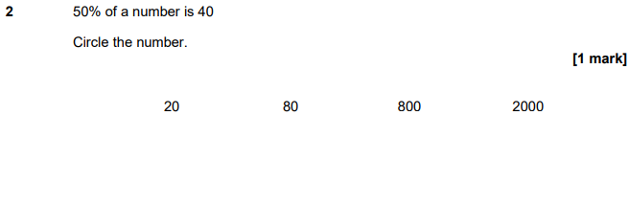
AQA Tuesday 21 May 2019 – Morning (Non-Calculator) Foundation Tier

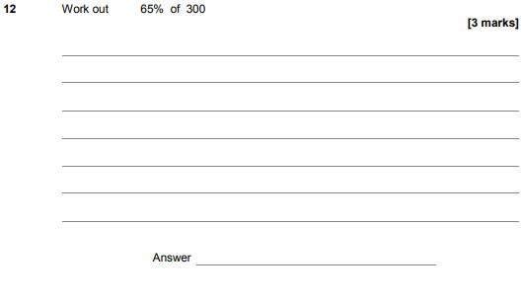

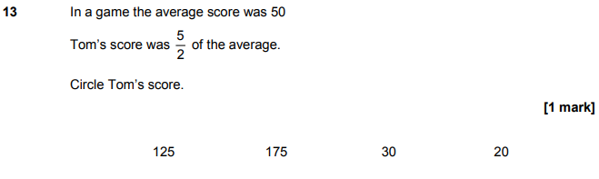
AQA Thursday 6 June 2019 – Morning (Calculator) Foundation Tier

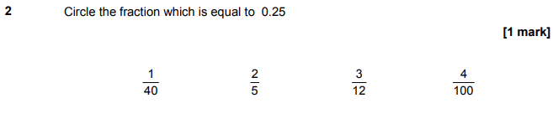

AQA Thursday 6 June 2019 – Morning (Calculator) Foundation Tier

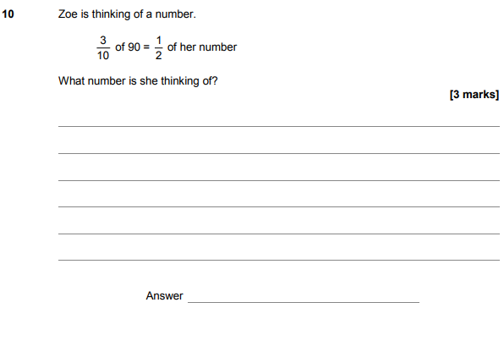
AQA Thursday 11 June 2019 – Morning (Calculator) Foundation Tier

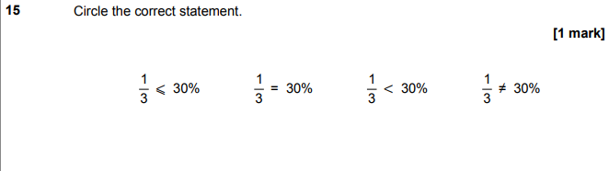

AQA Tuesday 6 November 2018 – Morning (Non-Calculator) Foundation Tier

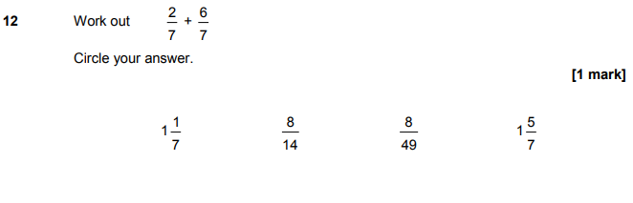

AQA Tuesday 6 November 2018 – Morning (Non-Calculator) Foundation Tier

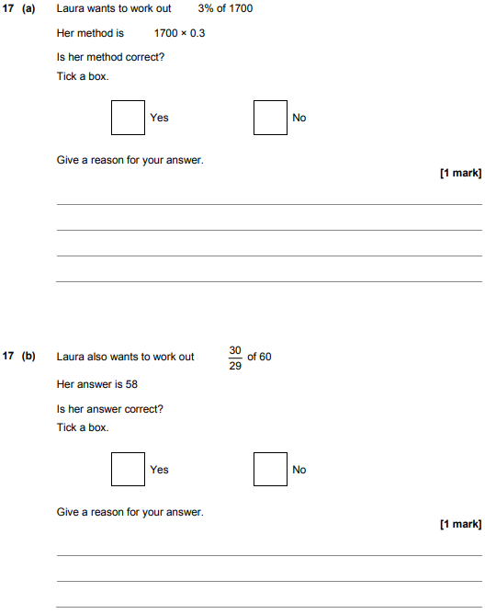

AQA Tuesday 6 November 2018 – Morning (Non-Calculator) Foundation Tier

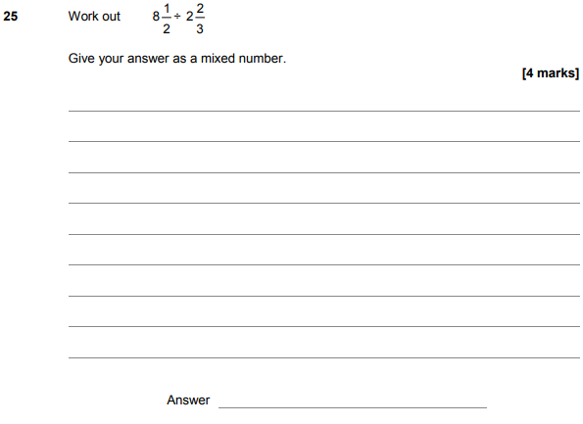

AQA Thursday 24 May 2018 – Morning (Non-Calculator) Foundation Tier

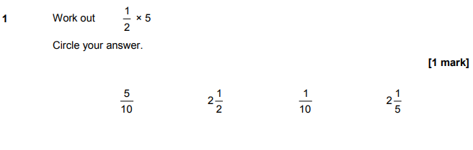

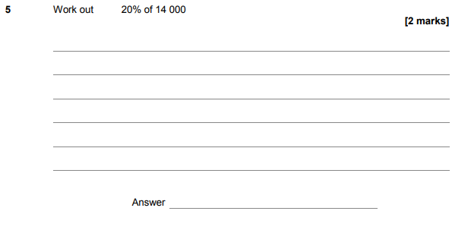

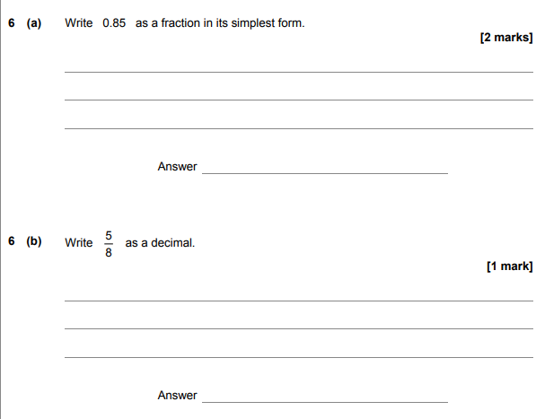

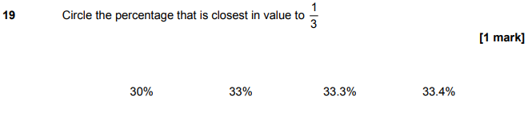

AQA Thursday 7 June 2018 – Morning (Calculator) Foundation Tier

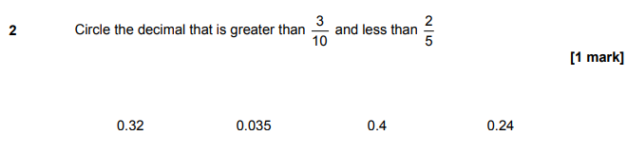
AQA Tuesday 12 June 2018 – Morning (Calculator) Foundation Tier

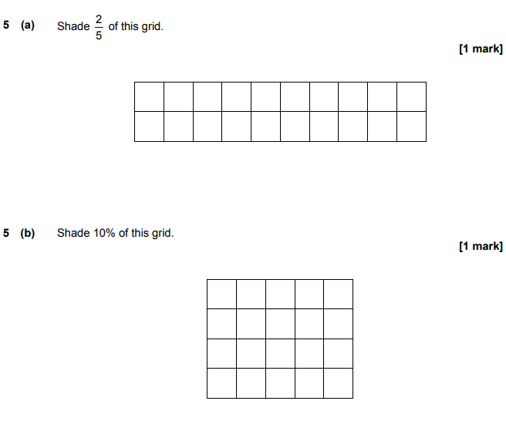

AQA Thursday 2 November 2017 – Morning (Non-Calculator) Foundation Tier

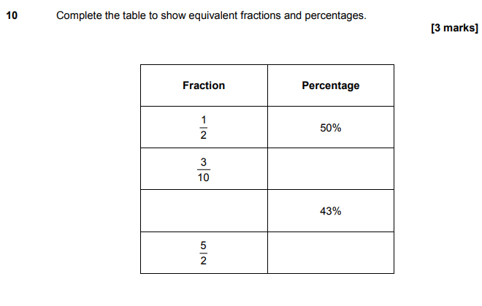
AQA Thursday 25 May 2017– Morning (Non-Calculator) Foundation Tier

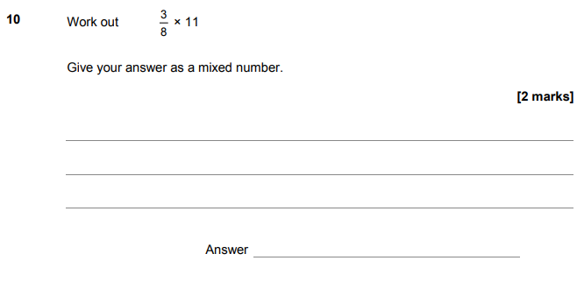
AQA Thursday 8 June 2017– Morning (Calculator) Foundation Tier

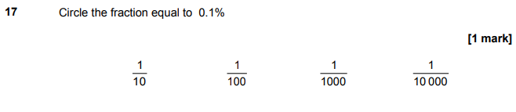
AQA Sample Paper 1– Morning (Non-Calculator) Foundation Tier

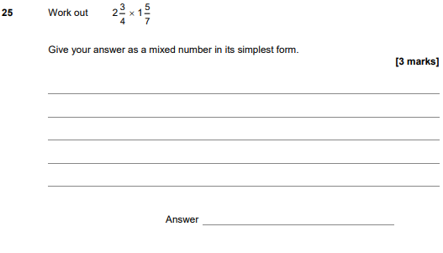

AQA Sample Paper 2– Morning (Calculator) Foundation Tier

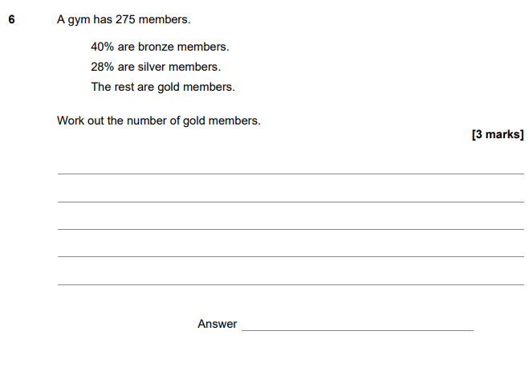

AQA Sample Paper 3– Morning (Calculator) Foundation Tier

